Visit Tracking Utility

Purpose
This software will help your company track:
- Company / Organisation / Department visits
- Employee-wise field visits
- Travel mode and travel expense calculation
- Visit funnel management
- Business outcome tracking
- Lead-to-order conversion tracking
- Daily, monthly, and team performance reporting
This system will be especially useful for your sales team, business development team, project team, and management.

1. Core Business Objective
The software should allow your team to:
- Create and manage visit entries
- Record whom they visited
- Record purpose of visit
- Track travel distance and vehicle type
- Auto-calculate visit expense
- Track visit status in funnel stages
- Track outcome generated from visit
- Measure conversion and business value
- Monitor employee performance
- Generate reports for management

2. Main Functional Areas
The software should have the following modules:

A. Master Management
Used to configure base data.

Masters to maintain:
- Company Master
- Organisation Master
- Department Master
- Contact Person Master
- Employee Master
- Designation Master
- Visit Purpose Master
- Funnel Stage Master
- Outcome Type Master
- Expense Rate Master
- Location Master
- Vehicle Type Master

B. Visit Entry Management
Main module where employee enters visit details.

Visit entry should capture:
- Visit date
- Employee name
- Employee designation
- Company / Organisation / Department visited
- Contact person
- Contact number
- City / location
- Visit type
- Purpose of visit
- Discussion summary
- Next action
- Next follow-up date
- Travel mode
- Distance travelled
- Expense rate per km
- Auto expense calculation
- Funnel stage
- Expected business value
- Outcome generated
- Order probability
- Remarks
- Attachment upload
- Geo location (optional)
- Check-in / Check-out time

C. Expense Calculation Module
This is one of the key modules as per your requirement.

Default rates:
- Two-wheeler rate = 4 per km
- Four-wheeler rate = 10 per km
These rates should be:
- configurable from admin panel
- effective date based
- editable anytime by authorised user

Expense formula:
Expense = Distance × Rate per km

Example:
- Distance = 25 km
- Two-wheeler rate = 4
- Expense = 25 × 4 = 100
If admin changes rate later:
- Two-wheeler = 5
- Four-wheeler = 12
Then future visits should use new rate.
Old visits should continue with stored historical rate.

Recommended feature:
At the time of visit save:
- system should capture the rate used
- not dynamically change old expense records after master update
So visit record should store:
- vehicle type
- distance
- rate applied
- total expense

D. Funnel Management Module
This module will track business progress from first visit to final closure.

Suggested funnel stages:
- Lead Identified
- Initial Visit Done
- Requirement Discussion
- Proposal Shared
- Demo Conducted
- Technical Discussion
- Commercial Negotiation
- Follow-up
- Order Expected
- Won
- Lost
- On Hold
Admin should be able to add / edit / deactivate stages.

Funnel tracking should show:
- total visits in each stage
- employee-wise funnel
- client-wise funnel
- department-wise funnel
- conversion from one stage to next
- stalled opportunities
- overdue follow-ups

E. Business Outcome Tracking Module
This module measures actual business result from visits.

Outcome types can include:
- Lead Generated
- Requirement Collected
- Proposal Opportunity
- Demo Scheduled
- Demo Completed
- Tender Opportunity
- Deal Under Process
- Order Received
- Payment Follow-up
- Relationship Visit
- Complaint Resolution
- No Outcome

Key outcome metrics:
- number of leads generated
- number of proposals created
- total pipeline value
- total confirmed business value
- visit-to-lead ratio
- lead-to-proposal ratio
- proposal-to-order ratio
- cost per lead
- cost per order
- employee productivity score

3. Suggested User Roles

1. Super Admin
- full control
- manage masters
- manage users and permissions
- configure expense rates
- view all reports
- export data

2. Admin
- manage visit data
- manage masters
- approve corrections
- generate reports

3. Team Lead / Manager
- view team visits
- assign follow-ups
- review funnel
- approve expenses
- monitor outcomes

4. Employee / Field Executive
- create and edit own visits
- add follow-up
- update funnel stage
- upload visit proof
- submit expense

5. Management / Director
- dashboard access
- business performance
- team productivity
- cost vs revenue reports

4. End-to-End Workflow

Step 1: Admin setup
Admin creates:
- employees
- organisations
- departments
- visit purposes
- expense rates
- funnel stages
- outcome types

Step 2: Employee logs visit
Employee enters:
- where visited
- whom visited
- purpose
- distance
- vehicle type
- discussion summary
- next action
- funnel stage
- expected value

Step 3: System calculates expense
System automatically calculates:
- rate per km
- travel cost
- stores final amount

Step 4: Follow-up tracking
System reminds:
- pending follow-up
- overdue meeting
- stalled opportunities

Step 5: Outcome update
Employee or manager updates:
- lead generated
- proposal submitted
- demo completed
- order won/lost

Step 6: Management reporting
Dashboard displays:
- total visits
- monthly expenses
- pipeline value
- conversion ratio
- employee performance
- client coverage

5. Suggested Screens / UI Modules

Login / Authentication
- email / mobile login
- password
- JWT based access
- role-based dashboard

Dashboard
Widgets:
- total visits today
- total visits this month
- pending follow-ups
- total travel expenses
- stage-wise funnel
- business outcome summary
- top performers
- client coverage

Visit Entry Form
Fields:
- visit date
- employee
- company / organisation / department
- contact person
- location
- purpose
- vehicle type
- distance
- rate
- total expense
- funnel stage
- expected business amount
- next follow-up
- remarks
- attachment

Visit List Screen
Filters:
- employee
- date range
- company
- department
- stage
- outcome
- location
- status
Actions:
- view
- edit
- print
- export

Follow-up Screen
- follow-up date
- pending tasks
- overdue cases
- reminders

Funnel Pipeline Screen
- kanban style or stage-wise column
- deal value
- ageing
- next action

Expense Summary Screen
- daily expense
- monthly expense
- employee-wise expense
- vehicle-wise expense

Reports Screen
- employee visit report
- organisation visit report
- department visit report
- funnel progress report
- business conversion report
- expense statement
- ROI report

Master Screens
- organisation master
- department master
- rate master
- vehicle master
- outcome master
- purpose master

6. Recommended Technology Stack
Since you usually work on Microsoft-compatible enterprise systems, this will fit well:

Frontend
- React + TypeScript
- Vite
- Material UI or Ant Design

Backend
- ASP.NET Core 8 Web API
- Clean Architecture

Database
- MySQL 8

ORM
- Entity Framework Core

Authentication
- JWT Authentication
- Refresh Token
- Role-Based Access Control

Hosting
- Windows Server 2022
- IIS Hosting

Optional
- Google Maps integration for distance/location
- Excel export
- PDF reports
- WhatsApp/email reminder integration

7. Suggested Database Design

1. Users
- Id
- FullName
- Email
- Mobile
- PasswordHash
- RoleId
- DesignationId
- DepartmentId
- IsActive
- CreatedAt

2. Roles
- Id
- RoleName

3. Employees
- Id
- EmployeeCode
- UserId
- DesignationId
- ReportingManagerId
- LocationId
- IsActive

4. Companies
- Id
- CompanyName
- CompanyType
- IndustryType
- Address
- City
- State
- Pincode
- IsActive

5. Organisations
- Id
- OrganisationName
- CompanyId
- Address
- City
- State
- IsActive

6. Departments
- Id
- DepartmentName
- OrganisationId
- IsActive

7. ContactPersons
- Id
- CompanyId / OrganisationId / DepartmentId
- Name
- Designation
- Mobile
- Email
- Remarks
- IsActive

8. VisitPurposes
- Id
- PurposeName
- IsActive

9. VehicleTypes
- Id
- VehicleName
- DefaultRatePerKm
- IsActive
Example:
- Two Wheeler
- Four Wheeler

10. ExpenseRates
- Id
- VehicleTypeId
- RatePerKm
- EffectiveFrom
- EffectiveTo
- IsActive

11. FunnelStages
- Id
- StageName
- StageOrder
- IsClosedStage
- IsWonStage
- IsLostStage
- IsActive

12. OutcomeTypes
- Id
- OutcomeName
- IsRevenueLinked
- IsActive

13. Visits
- Id
- VisitCode
- VisitDate
- EmployeeId
- CompanyId
- OrganisationId
- DepartmentId
- ContactPersonId
- VisitPurposeId
- DiscussionSummary
- NextAction
- NextFollowUpDate
- VehicleTypeId
- DistanceKm
- RateAppliedPerKm
- TravelExpenseAmount
- FunnelStageId
- OutcomeTypeId
- ExpectedBusinessValue
- ActualBusinessValue
- ProbabilityPercent
- Status
- CheckInTime
- CheckOutTime
- Latitude
- Longitude
- Remarks
- AttachmentPath
- CreatedBy
- CreatedAt
- UpdatedAt

14. VisitFollowUps
- Id
- VisitId
- FollowUpDate
- FollowUpRemarks
- FunnelStageId
- OutcomeTypeId
- ExpectedBusinessValue
- ActualBusinessValue
- NextFollowUpDate
- CreatedBy
- CreatedAt

15. VisitAttachments
- Id
- VisitId
- FileName
- FilePath
- FileType
- UploadedAt

16. ExpenseApprovals
- Id
- VisitId
- SubmittedBy
- ApprovedBy
- ApprovalStatus
- ApprovalRemarks
- SubmittedAt
- ApprovedAt

17. AuditLogs
- Id
- TableName
- RecordId
- ActionType
- OldValueJson
- NewValueJson
- ActionBy
- ActionAt

8. Expense Calculation Logic

Rule table
Vehicle Type | Default Rate
Two Wheeler | 4
Four Wheeler | 10

Logic
- User selects vehicle type
- User enters distance in km
- System fetches active rate based on date
- Expense auto-calculates
- Rate is stored in visit record

Formula:
TravelExpenseAmount = DistanceKm × RateAppliedPerKm

Example:
- Vehicle = Four Wheeler
- Distance = 48 km
- Rate = 10
- Expense = 480

9. Funnel Management Logic
Each visit can be mapped to a stage.

Example scenario:
- First meeting with university = Lead Identified
- Requirement collection = Requirement Discussion
- Demo given = Demo Conducted
- Proposal submitted = Proposal Shared
- Negotiation = Commercial Negotiation
- Order received = Won

Business rules:
- stage can be updated through follow-up
- closed opportunities marked as Won / Lost
- ageing should be visible per stage
- overdue follow-up should be highlighted

10. Business Outcome Metrics
The system should calculate the following KPIs:

Activity Metrics
- Total visits
- Employee-wise visits
- Company-wise visits
- Department-wise visits
- Monthly visit trends

Expense Metrics
- Total travel expense
- Employee-wise travel expense
- Vehicle-wise expense
- Cost per visit

Funnel Metrics
- Total leads
- Total active opportunities
- Total won
- Total lost
- Stage-wise count
- Stage-wise pipeline value

Conversion Metrics
- Visit to lead conversion %
- Lead to proposal conversion %
- Proposal to demo conversion %
- Demo to order conversion %
- Overall closure rate %

ROI Metrics
- Cost incurred vs business generated
- Cost per lead
- Cost per proposal
- Cost per order
- Revenue per employee

11. Suggested Dashboards

A. Management Dashboard
- total visits this month
- total expenses this month
- total pipeline value
- total won value
- total lost value
- top employees
- stage-wise funnel chart
- business conversion chart

B. Employee Dashboard
- today’s visits
- pending follow-ups
- monthly distance travelled
- monthly expense
- opportunities assigned
- won deals

C. Manager Dashboard
- team visit count
- team expenses
- overdue follow-up
- stagnant deals
- conversion performance

12. Reports Required
The software should provide downloadable reports in Excel and PDF.

Standard reports:
- Daily Visit Report
- Date Range Visit Report
- Employee Visit Summary
- Organisation Visit Summary
- Department Visit Summary
- Expense Report
- Vehicle-wise Expense Report
- Funnel Stage Report
- Follow-up Pending Report
- Business Outcome Report
- Conversion Analysis Report
- Monthly Productivity Report
- Cost vs Revenue Report

13. Suggested API Modules

Authentication APIs
- login
- refresh token
- logout
- change password

Master APIs
- create/update/list companies
- create/update/list organisations
- create/update/list departments
- create/update/list contact persons
- create/update/list visit purposes
- create/update/list vehicle types
- create/update/list rates
- create/update/list funnel stages
- create/update/list outcome types

Visit APIs
- create visit
- update visit
- get visit by id
- list visits with filters
- add attachment
- add follow-up
- update stage
- submit expense
- approve expense

Dashboard APIs
- management dashboard
- employee dashboard
- manager dashboard

Report APIs
- export visit report
- export expense report
- export funnel report
- export outcome report

14. Recommended Validation Rules
- Visit date cannot be blank
- Employee mandatory
- Company / organisation / department mandatory
- Vehicle type mandatory if expense is to be calculated
- Distance must be numeric and positive
- Funnel stage mandatory
- Follow-up date required when next action exists
- Rate should be fetched from active configuration
- Only authorised users can modify expense rate
- Only managers/admin can approve expense
- Closed Won/Lost stages should require outcome remarks

15. Security and Control Features
- role-based access control
- menu permission based on role
- audit trail for visit changes
- audit trail for rate changes
- approval workflow for expense
- attachment restriction and secure upload
- activity logs
- user-wise data access restriction
- soft delete for masters

16. Advanced Features You Can Add Later
These are not mandatory in phase 1 but highly useful:

Phase 2 options
- mobile app for field users
- GPS-based visit marking
- map-based route tracking
- automatic distance calculation using maps
- visit selfie/photo proof
- voice notes for discussion summary
- reminder notifications on WhatsApp/email
- lead scoring
- AI-based visit productivity insights
- reimbursement claim workflow
- attendance linkage
- calendar sync

17. Recommended Development Phases

Phase 1: Core system
- user login
- masters
- visit entry
- expense calculation
- funnel management
- follow-up tracking
- dashboards
- reports

Phase 2: Approval and analytics
- expense approval
- pipeline analytics
- outcome dashboards
- conversion reporting

Phase 3: Mobility and automation
- mobile app
- GPS
- notifications
- AI analytics

18. Suggested Screen Flow
- Login
- Dashboard
- Masters Setup
- Visit Entry
- Visit List
- Follow-up Update
- Expense Summary
- Funnel Pipeline
- Reports
- Admin Settings

19. Sample Use Case

Example:
Employee visits:
- Organisation: MP Board
- Department: Examination Department
- Purpose: OMS Demo
- Vehicle: Four Wheeler
- Distance: 35 km
- Rate: 10/km
- Expense: 350
- Funnel Stage: Demo Conducted
- Outcome: Proposal Opportunity
- Expected Value: 12,00,000
- Next Follow-up: 18 March 2026
System will automatically store:
- visit history
- travel cost
- funnel movement
- business potential
- follow-up reminder

20. Final Recommendation for Your Team
For your team, I recommend building this as a web-based enterprise MIS utility with these core pillars:
- Visit Management
- Expense Automation
- Funnel Tracking
- Business Outcome Monitoring
- Management Dashboard
- Role-Based Control
This will become not just a visit register, but a complete business development performance system.

21. Best Project Name Suggestions
You can name this software as:
- Agnigate VisitPro
- FieldTrack 360
- BizVisit MIS
- Visit & Funnel Tracker
- Sales Visit Intelligence System
- BD Visit Management Utility

22. What Your Development Team Should Build First
Tell your team to start in this order:

Priority 1
- Login
- User roles
- Masters
- Visit entry form
- Expense auto-calculation

Priority 2
- Follow-up management
- Funnel stage movement
- Outcome tracking

Priority 3
- Dashboards
- Reports
- Export to Excel/PDF

Priority 4
- GPS / mobile app / AI insights

SOFTWARE REQUIREMENT SPECIFICATION (SRS)

Project Name
Agnigate Visit Tracking & Business Funnel Management System

Version
Version 1.0

Prepared For
Development Team / Intern Software Developers

Prepared By
Agnigate Technologies Pvt. Ltd.

Purpose of Document
This document provides detailed requirements for designing and developing the Visit Tracking Utility that will allow the organization to track:
- Company / Organisation / Department visits
- Travel expenses based on vehicle type
- Sales funnel management
- Business outcomes and conversions
- Employee productivity and visit performance
The document will serve as the technical blueprint for development.

1. Introduction

1.1 Purpose of the Software
The system will provide a centralized platform to:
- Track employee visits
- Monitor sales funnel progress
- Calculate travel expenses automatically
- Track business opportunities generated from visits
- Provide analytics and reports to management
The system will help improve business development tracking, employee accountability, and revenue forecasting.

1.2 Scope of the Software
The Visit Tracking System will:
- Record all visits to companies, organizations, or departments.
- Track travel distance and calculate expense.
- Allow configurable expense rates for vehicle types.
- Maintain a sales funnel pipeline.
- Track outcomes of visits (lead, proposal, demo, order).
- Generate analytics dashboards.
- Provide management reports.

1.3 Intended Users
User Type | Description
Super Admin | System configuration and master management
Admin | Data management and reporting
Manager | Team monitoring and approvals
Employee | Visit entry and updates
Management | Business analytics

2. Overall System Description

2.1 Product Perspective
The system will be a web-based enterprise application.

Technology Stack
Frontend
React + TypeScript
Vite
Material UI / Ant Design
Backend
ASP.NET Core 8 Web API
Clean Architecture
Database
MySQL 8
Authentication
JWT Authentication
Role Based Access Control
Hosting
Windows Server 2022
IIS Hosting

2.2 System Objectives
The system will help achieve:
- Digital visit tracking
- Automatic expense calculation
- Business opportunity monitoring
- Performance measurement
- Business pipeline visibility

3. Functional Requirements

3.1 User Authentication Module

Features
User login
User logout
Password reset
Role based access

Inputs
- Email / Username
- Password

Outputs
- Authentication token
- User role
- Dashboard access

3.2 User Management Module
Admin should be able to:
- Create users
- Edit users
- Assign roles
- Assign reporting managers
- Activate / deactivate users

Fields
User ID
Name
Email
Mobile
Designation
Department
Role
Manager

3.3 Master Data Management
System should support the following masters.

3.3.1 Company Master
Fields:
Company ID
Company Name
Industry Type
Address
City
State
Status

3.3.2 Organisation Master
Fields:
Organisation ID
Organisation Name
Company ID
Address
City
State
Status

3.3.3 Department Master
Fields:
Department ID
Department Name
Organisation ID
Status

3.3.4 Contact Person Master
Fields:
Contact Person ID
Name
Designation
Mobile Number
Email
Company / Organisation / Department

3.3.5 Visit Purpose Master
Examples:
- Product Demo
- Proposal Discussion
- Requirement Collection
- Tender Discussion
- Relationship Meeting
Fields
Purpose ID
Purpose Name
Status

3.3.6 Vehicle Type Master
Default values:
Vehicle Type | Rate Per KM
Two Wheeler | 4
Four Wheeler | 10
Admin should be able to change the rates.
Fields
Vehicle ID
Vehicle Name
Default Rate
Status

3.3.7 Expense Rate Master
Fields
Rate ID
Vehicle Type
Rate Per KM
Effective From
Effective To
Rates must be configurable.

3.3.8 Funnel Stage Master
Example stages
Lead Identified
Initial Visit
Requirement Discussion
Proposal Shared
Demo Conducted
Commercial Negotiation
Order Expected
Won
Lost
Fields
Stage ID
Stage Name
Stage Order
Status

3.3.9 Outcome Master
Examples
Lead Generated
Demo Scheduled
Proposal Opportunity
Tender Opportunity
Order Received
No Outcome
Fields
Outcome ID
Outcome Name
Status

4. Visit Management Module
This is the core module of the system.
Employees will record every visit.

4.1 Visit Entry
Fields
Visit ID
Visit Date
Employee Name
Company / Organisation / Department
Contact Person
Location
Purpose of Visit
Discussion Summary
Next Action
Next Follow-up Date
Travel Details
Vehicle Type
Distance (KM)
Rate Per KM
Total Expense
Business Tracking
Funnel Stage
Outcome Type
Expected Business Value
Actual Business Value
Probability Percentage
Other Fields
Remarks
Attachment
Check In Time
Check Out Time

5. Expense Calculation Module
System must automatically calculate travel expenses.

Default Expense Rates
Two Wheeler = 4 per KM
Four Wheeler = 10 per KM
Rates should be editable by Admin.

Expense Calculation Logic
Expense = Distance × Rate per KM
Example
Distance = 25 KM
Vehicle = Two Wheeler
Rate = 4
Expense = 25 × 4 = 100
The system must store:
Distance
Rate Used
Total Expense
Historical data should not change if rate is updated later.

6. Funnel Management Module
The system will track visit progress through stages.
Example:
Lead Identified
Requirement Discussion
Demo Conducted
Proposal Submitted
Negotiation
Order Won
Managers should be able to view pipeline.

7. Follow-Up Management
Users should be able to schedule follow-ups.
Fields
Follow-up Date
Follow-up Notes
Next Action
Updated Funnel Stage
System should show:
Pending follow-ups
Overdue follow-ups

8. Business Outcome Tracking
System should track business generated from visits.
Examples
Lead generated
Proposal created
Demo conducted
Order received
Metrics should include
Pipeline value
Won value
Lost value

9. Dashboard Module

Employee Dashboard
Today's visits
Pending follow-ups
Monthly distance
Monthly expenses

Manager Dashboard
Team visits
Team expenses
Pipeline value
Overdue follow-ups

Management Dashboard
Total visits
Total expenses
Pipeline value
Conversion ratio
Top performing employees

10. Reporting Module
System must generate reports.

Required Reports
Daily Visit Report
Employee Visit Report
Company Visit Report
Expense Report
Vehicle Expense Report
Funnel Report
Follow-up Report
Outcome Report
Conversion Report
Reports should support:
Excel Export
PDF Export

11. Non Functional Requirements

11.1 Performance
System should support:
Minimum 100 concurrent users
Response time
Less than 3 seconds per request

11.2 Security
Features required:
Role based access control
Secure password hashing
JWT authentication
Data encryption
Audit logging

11.3 Scalability
The system should support scaling to:
1000+ users

11.4 Availability
System uptime target:
99%

12. Database Design Overview
Main tables:
Users
Roles
Employees
Companies
Organisations
Departments
Contacts
VisitPurposes
VehicleTypes
ExpenseRates
FunnelStages
OutcomeTypes
Visits
VisitFollowUps
VisitAttachments

13. API Requirements

Authentication APIs
Login
Logout
Refresh Token

Master APIs
Create Company
Update Company
Create Department
Create Vehicle Type

Visit APIs
Create Visit
Update Visit
Get Visit
List Visits
Add Follow-up

Dashboard APIs
Employee Dashboard
Manager Dashboard
Management Dashboard

Report APIs
Visit Report
Expense Report
Funnel Report

14. Validation Rules
Visit date required
Employee required
Company required
Distance must be numeric
Vehicle type required
Funnel stage required

15. User Interface Requirements
The system should include:
Login Page
Dashboard
Visit Entry Screen
Visit List Screen
Follow-up Screen
Expense Summary Screen
Funnel Pipeline Screen
Reports Screen
Admin Master Screens

16. Future Enhancements
Mobile application for field staff
GPS tracking
Google Map distance calculation
WhatsApp follow-up reminders
AI productivity analytics

17. Development Milestones

Phase 1
User authentication
Master management
Visit entry
Expense calculation

Phase 2
Funnel tracking
Follow-ups
Outcome tracking

Phase 3
Dashboards
Reports
Analytics

18. Acceptance Criteria
The system will be considered complete when:
- Visit entry works
- Expense calculation works
- Funnel tracking works
- Reports generate correctly
- Dashboards display analytics

19. Deployment Requirements
Server
Windows Server 2022
Hosting
IIS
Database
MySQL 8

20. Project Deliverables
Development team must deliver:
Source Code
Database Schema
API Documentation
Deployment Guide
User Manual

Full System Architecture Diagram

Layer-Wise Architecture Explanation

1. User Layer
These are the people who will use the system:
- Employee / Field Executive
- Manager / Team Lead
- Admin / Super Admin
- Management / Director
They access the software through browser-based login.

2. Frontend Layer
This will be built using:
- React
- TypeScript
- Vite
- Material UI or Ant Design

Main frontend modules:
- Login screen
- Dashboard
- Visit entry form
- Follow-up management
- Funnel tracking
- Expense reports
- Master management
- Reporting screens
This layer will send requests to backend APIs.

3. Backend API Layer
This will be built using:
- ASP.NET Core 8 Web API
This layer will:
- receive requests from frontend
- validate data
- apply business rules
- communicate with database
- generate reports
- handle authentication and permissions

4. Application Services Layer
This is the main business logic layer.

Major services:
Authentication Service
- login
- JWT generation
- token validation
- refresh tokens
User & Role Management Service
- user creation
- role assignment
- permissions
Visit Management Service
- create visit
- update visit
- get visit details
- visit history
Expense Calculation Service
- fetch vehicle rate
- calculate travel cost
- store historical applied rate
Funnel Management Service
- maintain stage movement
- track pipeline
- monitor stage ageing
Follow-up Management Service
- save next actions
- overdue reminders
- follow-up history
Business Outcome Tracking Service
- lead generated
- demo done
- proposal submitted
- order won/lissed
Dashboard & Analytics Service
- employee dashboard
- manager dashboard
- management KPI dashboard
Reporting Service
- Excel reports
- PDF reports
- filters and exports
Master Data Management Service
- company
- organisation
- department
- contact
- outcome
- vehicle
- rates
- stages
Attachment Management Service
- upload visit documents
- store photo/proof
- retrieve files
Audit Log Service
- record every important change
- maintain traceability

5. Domain Layer
This contains the core entities of the system.

Main entities:
- Users
- Roles
- Employees
- Companies
- Organisations
- Departments
- Contacts
- Visits
- Visit Follow-ups
- Vehicle Types
- Expense Rates
- Funnel Stages
- Outcome Types
- Attachments
- Audit Logs
This layer contains the business model of the software.

6. Infrastructure Layer
This layer handles technical implementation details.

Components:
Entity Framework Core
- ORM for DB communication
MySQL 8
- main transactional database
File Storage
- visit attachments
- proofs
- documents
JWT Provider
- secure token generation and validation
Excel / PDF Export Engine
- downloadable reports
Email / Notification Service
- follow-up reminders
- optional alerts
Maps / Distance API
- optional future integration for automatic distance calculation

7. Deployment Layer
This is the hosting environment.

Recommended deployment:
- Windows Server 2022
- IIS Hosting
- HTTPS / SSL
- MySQL Backup & Restore
- Production + UAT environment

Recommended Clean Architecture Structure
Your intern team should use this project structure:
VisitTrackingSolution
│
├── VisitTracking.API
│ ├── Controllers
│ ├── Middleware
│ ├── Filters
│ ├── Program.cs
│
├── VisitTracking.Application
│ ├── Interfaces
│ ├── Services
│ ├── DTOs
│ ├── Features
│ ├── Validators
│
├── VisitTracking.Domain
│ ├── Entities
│ ├── Enums
│ ├── Common
│
├── VisitTracking.Infrastructure
│ ├── Persistence
│ ├── Repositories
│ ├── Identity
│ ├── FileStorage
│ ├── Reports
│ ├── Notifications
│
└── VisitTracking.Shared
├── Constants
├── Helpers
├── CommonModels

Request Flow Diagram

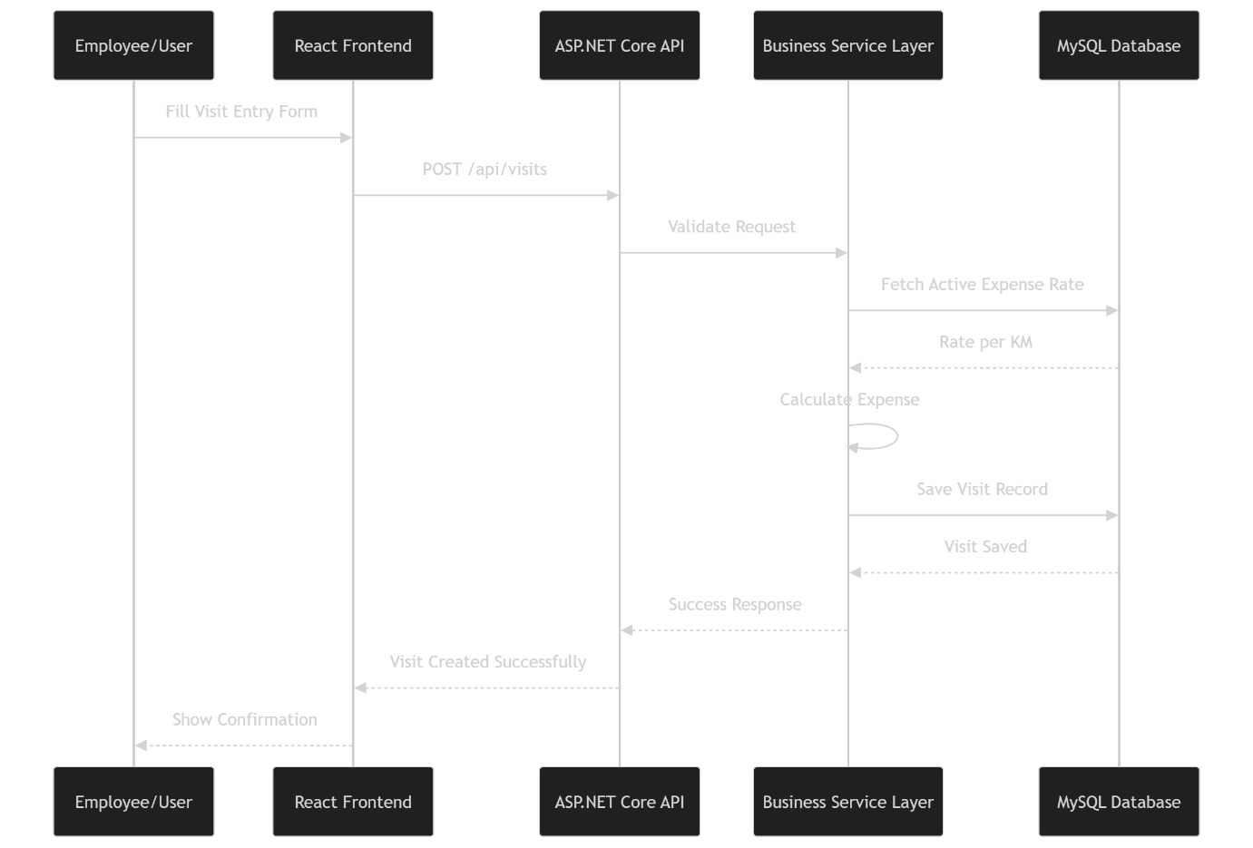

Expense Calculation Architecture

Funnel Tracking Architecture

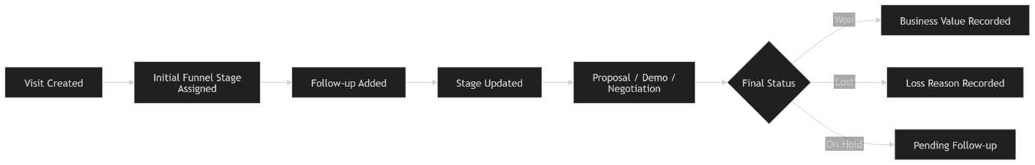

Dashboard Data Architecture

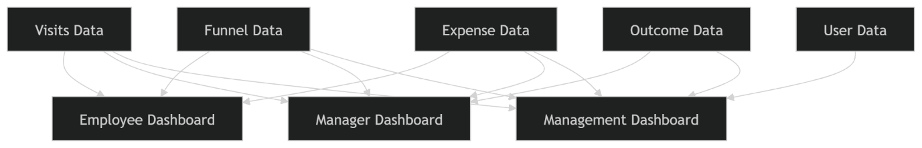

Recommended Security Architecture

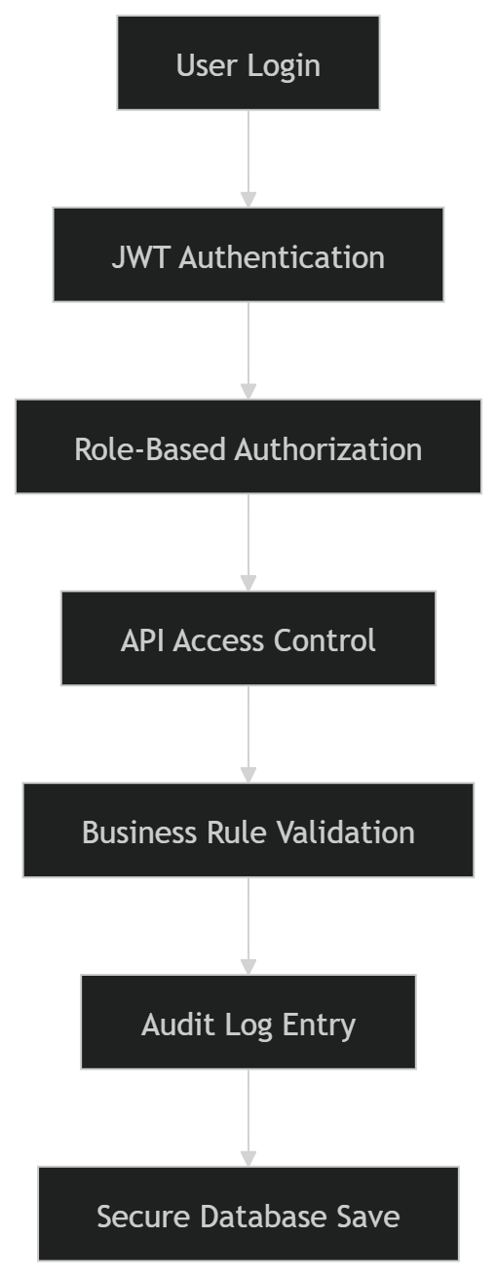

Intern Development Guidance
Tell your interns to build in this order:

Phase 1
- Login
- Role management
- Master setup
- Visit entry
- Expense calculation

Phase 2
- Follow-up module
- Funnel stage update
- Outcome tracking

Phase 3
- Dashboard
- Reports
- Exports
- Audit logs

Phase 4
- Notifications
- GPS integration
- Mobile responsiveness

Final Architecture Recommendation
For your use case, the best architecture is:
- Frontend: React + TypeScript
- Backend: ASP.NET Core 8 Web API
- Architecture Style: Clean Architecture
- Database: MySQL 8
- Auth: JWT + Refresh Token
- Hosting: Windows Server + IIS
This is suitable because it is:
- scalable
- secure
- easy for interns to maintain in modules
- enterprise-ready
- future-ready for mobile app and GPS features

ER Diagram – Visit Tracking Utility

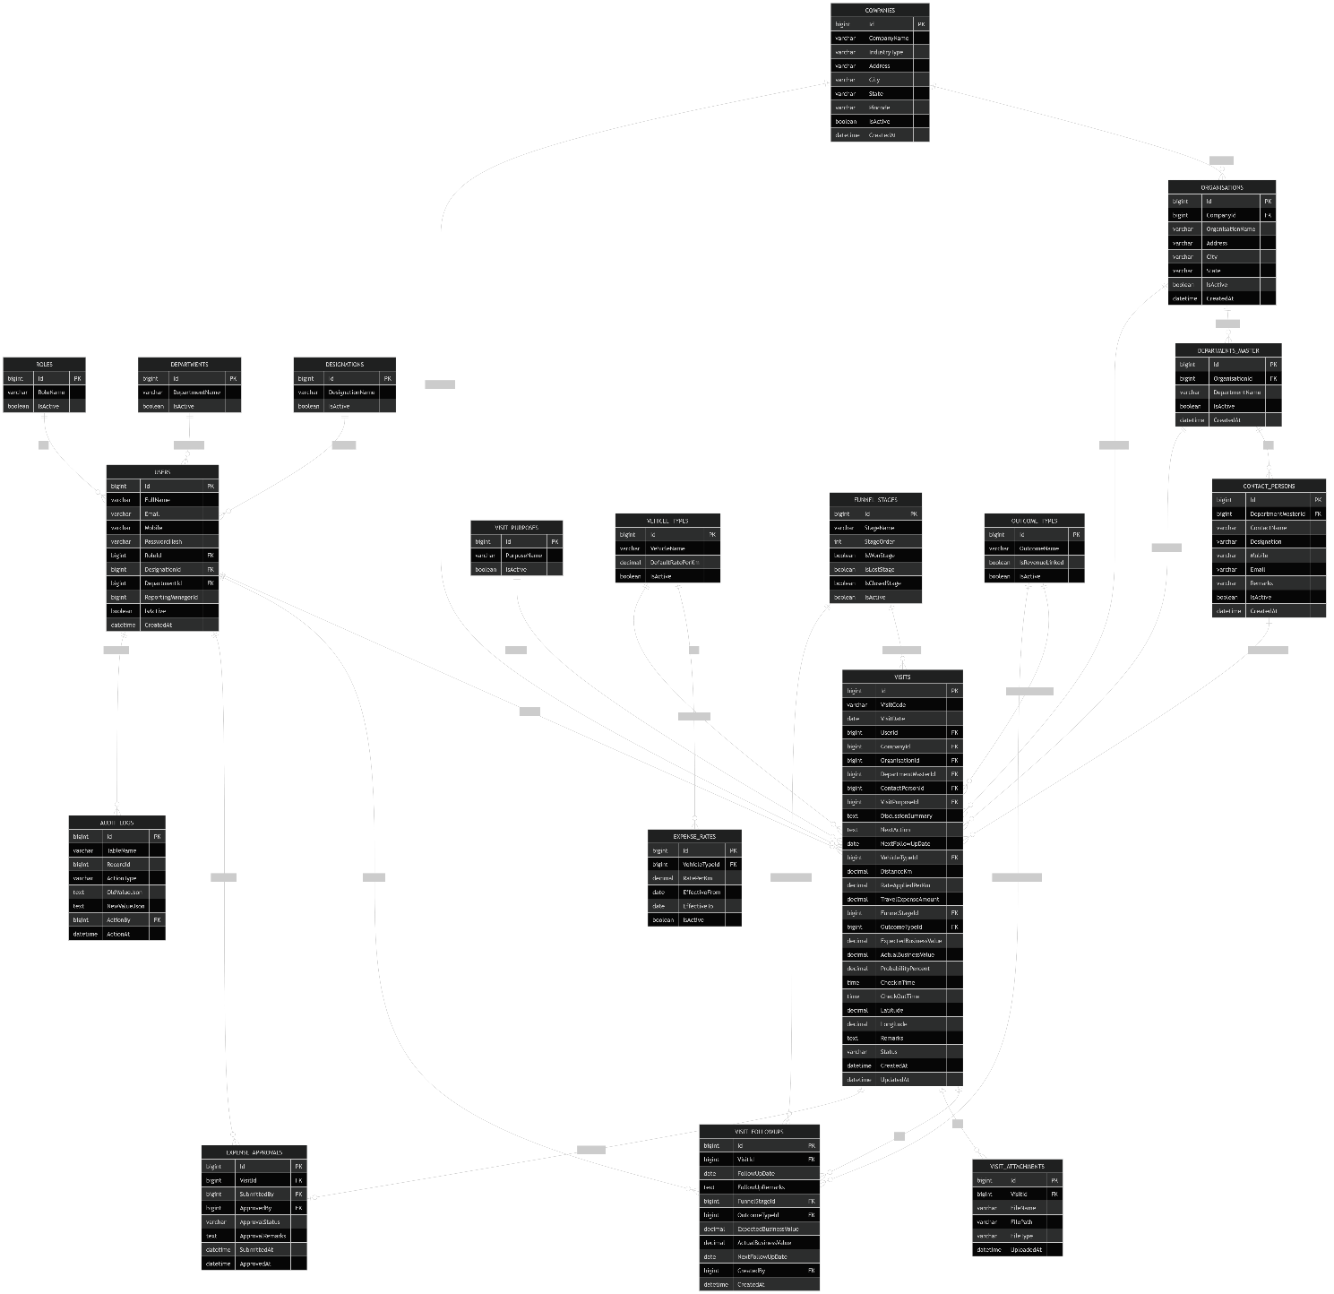

Database Structure Explanation

1. User and Access Tables

ROLES
Stores roles such as:
- Super Admin
- Admin
- Manager
- Employee
- Management

USERS
Stores login users and employee details.
Each user will have:
- role
- designation
- department
- reporting manager

DESIGNATIONS
Examples:
- Business Development Executive
- Manager
- Admin
- Director

DEPARTMENTS
Internal company departments:
- Sales
- Marketing
- Projects
- Accounts

2. Client/Visit Target Structure
This software tracks visits to external entities in hierarchy form:

COMPANIES
Top-level company or institution.
Example:
- MP Board
- Bhoj University
- ITI Limited

ORGANISATIONS
Sub-unit or institution under company, where applicable.
Example:
- Examination Wing
- University Campus Office

DEPARTMENTS_MASTER
Specific departments visited.
Example:
- Registrar Office
- Examination Department
- IT Department

CONTACT_PERSONS
Stores officials met during the visit.
Example:
- Registrar
- Controller of Examination
- IT Officer

3. Visit Configuration Tables

VISIT_PURPOSES
Examples:
- Demo
- Proposal Discussion
- Requirement Gathering
- Payment Follow-up
- Tender Meeting

VEHICLE_TYPES
Examples:
- Two Wheeler
- Four Wheeler

EXPENSE_RATES
Stores rate history.
Examples:
- Two Wheeler = 4/km
- Four Wheeler = 10/km
This table allows:
- future rate change
- historical record preservation

FUNNEL_STAGES
Examples:
- Lead Identified
- Initial Visit
- Requirement Discussion
- Demo Conducted
- Proposal Shared
- Negotiation
- Won
- Lost

OUTCOME_TYPES
Examples:
- Lead Generated
- Demo Scheduled
- Tender Opportunity
- Proposal Created
- Order Received
- No Outcome

4. Core Transaction Tables

VISITS
This is the main table.
Each visit record stores:
- who visited
- where visited
- whom met
- why visited
- vehicle and distance
- calculated expense
- funnel stage
- business value
- next action
- check-in/check-out
- remarks
This is the most important table in the software.

VISIT_FOLLOWUPS
Stores all follow-up movement for a visit.
This allows:
- stage progression history
- remarks history
- updated next follow-up
- expected and actual business value change
A single visit can have multiple follow-ups.

VISIT_ATTACHMENTS
Stores uploaded documents or proof.
Examples:
- meeting photo
- visiting slip
- proposal copy
- signed minutes
- tender document

EXPENSE_APPROVALS
Stores travel reimbursement approval workflow.
Useful when:
- employee submits visit expense
- manager/admin approves or rejects

AUDIT_LOGS
Stores change logs for important records.
Tracks:
- who changed
- what changed
- when changed
Useful for:
- admin control
- compliance
- debugging

Relationship Summary

Main relationships
- One role → many users
- One company → many organisations
- One organisation → many departments
- One department → many contact persons
- One user → many visits
- One visit → many follow-ups
- One visit → many attachments
- One vehicle type → many rate records
- One funnel stage → many visits/follow-ups
- One outcome type → many visits/follow-ups

Recommended Primary Keys and Foreign Keys

Primary keys
Use:
- bigint auto increment

Foreign keys
Should be enforced for:
- role-user
- company-organisation
- organisation-department
- department-contact
- user-visit
- visit-followup
- vehicle-rate
- visit-funnel
- visit-outcome

Recommended Indexing
Your interns should create indexes on:

VISITS
- VisitDate
- UserId
- CompanyId
- OrganisationId
- DepartmentMasterId
- FunnelStageId
- OutcomeTypeId
- NextFollowUpDate

VISIT_FOLLOWUPS
- VisitId
- FollowUpDate

EXPENSE_RATES
- VehicleTypeId
- EffectiveFrom
- EffectiveTo

USERS
- Email
- RoleId
This will improve report speed.

Business Logic Notes for Database

Expense logic
In VISITS table store:
- DistanceKm
- RateAppliedPerKm
- TravelExpenseAmount
This is important because if admin changes rates later, old visit expense should remain unchanged.

Funnel logic
Current stage should be stored in VISITS.
Movement history should be stored in VISIT_FOLLOWUPS.
This gives both:
- latest stage
- full trail of journey

Outcome logic
Current outcome in VISITS
Outcome history in VISIT_FOLLOWUPS

Recommended Additional Optional Tables
If you want more enterprise control later, add:

LOSS_REASONS
For lost deals:
- budget issue
- competitor won
- no requirement
- delayed by department

NOTIFICATIONS
For reminder alerts:
- follow-up due
- overdue case
- approval pending

LOGIN_HISTORY
Tracks:
- login date/time
- IP address
- device

SETTINGS
Stores:
- company-wide configuration
- default distance settings
- expense approval limits

Simplified Table Priority for Intern Team
Tell your interns to build the database in this order:

Phase 1 tables
- Roles
- Users
- Companies
- Organisations
- Departments_Master
- Contact_Persons
- Visit_Purposes
- Vehicle_Types
- Expense_Rates
- Funnel_Stages
- Outcome_Types
- Visits

Phase 2 tables
- Visit_FollowUps
- Visit_Attachments
- Expense_Approvals

Phase 3 tables
- Audit_Logs
- Notifications
- Loss_Reasons

Recommended Folder Mapping in Code
For your ASP.NET Core project:
Domain/Entities
- Role.cs
- User.cs
- Designation.cs
- Department.cs
- Company.cs
- Organisation.cs
- DepartmentMaster.cs
- ContactPerson.cs
- VisitPurpose.cs
- VehicleType.cs
- ExpenseRate.cs
- FunnelStage.cs
- OutcomeType.cs
- Visit.cs
- VisitFollowUp.cs
- VisitAttachment.cs
- ExpenseApproval.cs
- AuditLog.cs

Final Development Recommendation
For your intern team, this ER design is enough to start:
- Database creation
- Entity Framework models
- DbContext mapping
- Repository layer
- API module creation
Next best document for them is the API Contract Document, because after database design, the team will need:
- request models
- response models
- API endpoints
- validation rules
I will now prepare the Full API Contract Document for this software if you want.

